Team 3

Stephanie Balderama

Kisha Gladden

Summer Justice

Jewel Loff-Polk

My Personal Chef

**Overview**

Millions of Americans report that they are unable to eat healthy due to busy lives, long working hours, and the need for convenience. Health concerns limit food choices and add complexity to maintaining a healthy diet. *My Personal Chef* is a convenient, cost-effective food planning and delivery service offering a solution to meet these challenges. Meals are correlated with your personal health history to reduce conflicts with health conditions and provide personalized choices. *My Personal Chef* allows an individual or parent to schedule meals to be delivered directly to their office or child’s school. Operated on a subscription service, *My Personal Chef*  offers a large variety of choices, including only those recommended for the individual’s health profile or personal tastes, from which to choose. Our company is seeking capital investment to expand our network of ghost kitchens for food preparation and increase the scale of our marketing plan to reach additional markets.

**The Problem**

Three things are true today:

* Americans are busier than ever
* People need to do a better job of eating healthy
* COVID-19 has forever changed the way we live our lives.

Our service, *My Personal Chef*, provides a positive solution to all three.

A recent study published by Pew Research Center revealed that both parents in 46 percent of all two-parent households work full-time. Further, the portion of households with a mother who stays at home has declined to 26 percent from 47 percent in 1970. Nearly 25 percent of males and 33 percent of females reported working more than 40 hours per week. For those with college degrees, the numbers were even higher.

Many Americans surveyed in a study by the National Institute of Health identified several factors preventing them from maintaining a healthy diet, including that eating healthy takes too much time,  they were too busy to eat healthy, working at a job with a nontraditional schedule or limited schedule flexibility limits time to eat lunch, lack of convenience, and productive time lost going out to pick up lunch.

People with underlying health conditions or those that require a special diet have a difficult time finding meals that meet their specific dietary restrictions. With our *My Personal Chef* app, subscribers upload their health history, medications history, and dietary restrictions. During menu planning, subscribers are only shown meal choices which meet their specific needs. This eliminates potential complications and reduces the time it would take for the customer to research each meal to see if it meets their personal health needs.

Lastly, as COVID-19 continues to represent a threat to public gatherings, more people prefer to have meals delivered directly to their workplace and to eat lunch in the safety of their workplace. Our service eliminates possible potential exposure during dining in public restaurants, the loss of productive time and frustration of leaving work to pick up lunch, and paying for expensive delivery services like Grub Hub, Door Dash and UBER Eats of non-healthy meals.

**The Solution**

My Personal Chef delivers a cost-effective, convenient answer to eating healthy even with today’s busy lifestyles. My Personal Chef is a great supplement to a working professionals’ lunch routine and helps to make busy weeks a lot easier while adding healthy variety to their daily lives. Parents can provide My Personal Chef lunches for their children which are prepared for each child based on health restrictions. Meals are prepared by professional chefs in conjunction with a nutritionist with your health in mind. Subscriptions can include one to five meals per week, depending on personalized preference, and are delivered directly to the office or school Monday through Friday. Meal subscriptions can be paused, at the subscriber’s option, for vacations and holidays.

Unlike Splendid Spoon, Hello Fresh, Blue Apron and Epicurious, meals arrive ready-to-eat with no preparation required. Each meal is created “by you, just for you”. Subscribers never have anything on their plate that they didn’t select.

The flexibility of My Personal Chef allows our subscribers to:

* Create their personalized health profile, including allergies & dietary restrictions.
* Receive a personalized list of meal choices for entrees and side dish options
* Selection of herbs and spices allows the subscriber to get the right spice level
* Fully control meal choices to eliminate boredom.
* Received automated reminders to select food choices for up to 30 days in advance
* Edit meal choices up to 24 hours prior to delivery.

My Personal Chef uses locally sourced food purchased from independent certified-organic farms. All packaging used is 100% recyclable.

**Highlights**

Utilizing start-up capital of $500,000, we have been able to establish a customer base of 1000 monthly subscribers, generating $1.2 million in revenue over the past six months. We have established three ghost kitchens and have contracts with large employers, including Google, Wells Fargo Bank and Crossroads High School, a private hospital. We have achieved a 5% market penetration of customers in these three locations. Partnering with the employers to provide My Personal Chef as an employee benefit and identifying additional office buildings and schools are integral components of our enhanced marketing plan. We recently engaged a Marketing Director to extend our reach to new geographic employers in downtown Los Angeles, Newport Beach, and Irvine. Research data from the U.S. Census Bureau indicates that there are approximately 2.2 million people employed in these areas.

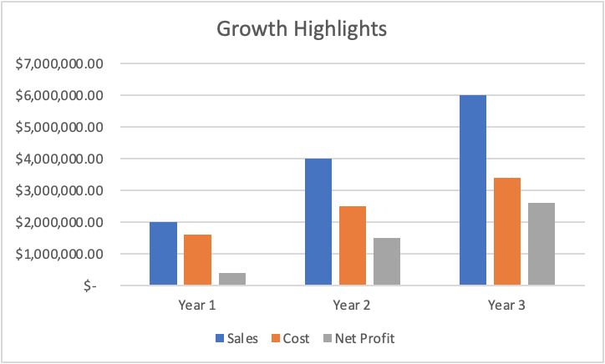

**Marketing Strategy**

Our marketing strategy focuses on the three key benefits of My Personal Chef:

* Convenience
* Wellness
* Choice

**Convenience**--Subscribers can order the meal subscription plan that meets their personal needs, from one to five days per week. Meals are delivered directly to their office or school. Subscribers place orders via our app up to 30 days in advance and can be changed up to 24 hours prior to delivery.

**Wellness**—Meals are selected specifically for each client based on their specific health history and dietary needs

**Choice**—Subscribers can select each entrée and side dish, level of spice, and condiments and receive their personally curated meal.

**Marketing Plan**

**Product:** My Personal Chef is a convenient food planning and delivery service  for  busy parents or professionals. Correlates with personal health history to lessen the potential that meals conflict with pre-existing conditions.

**Price:**  For $11 per meal, customers will receive one or two meals per day, five days per week. Subscription price is based on an average of 22 days per month. Subscription pricing for 2 meals per day is $484 per month. Customers can choose breakfast, lunch, or dinner.

**Promotion:** My Personal Chef can be found on all social media platforms; Facebook, Instagram, and Twitter. Customers can follow these outlets for the latest news and updates such as introductions to new ingredients and spices; new locations; and get questions answered.

**Place:** Our first ghost kitchen is located in downtown Los Angeles. Service is available to any location within a 25-mile radius.

**People:**  Our team members are dedicated to providing nutritious meals, using only the finest ingredients, for our clients. They are available to answer any questions.

**AT *My Personal Chef,***

**We believe that YOUR HEALTH IS YOUR WEALTH!**

*We also believe that one of the most important ways to maintain your body’s wealth is by depositing healthy and fresh meals into it!*

**W**ith competitors such as Splendid Spoon, Bistro MD & Blue Apron, Meal Master has set itself apart by allowing the customer to pick everything on their plate! Even the seasoning!

*No Salt?* No problem!                   *Gluten-Free?* You got it!

*Do you like it spicy?* Even Better!

**Resources Needed**

We are seeking a $1 million investment to meet 4 key goals:

* Establish 5 additional ghost kitchens in key geographic locations
* Expansion into three additional geographic markets
* Hire and train 5 marketing representatives to identify and engage additional employers and/or schools
* Reach 10,000 subscribers per month

We are seeking capital funding to support establishing an additional five ghost kitchens in key areas to support the expansion of our customer base into new geographic regions. Funding is also required to hire and train five marketing representatives to identify and engage employers and schools in these key areas-west Los Angeles, Newport Beach, and Irvine.

**Timeline**

We project full implementation of our strategic plan to be initiated within 45 days after receipt of funding and completed 12 months after funding.

**Financial Highlights**

With an additional investment of $1,000,000 we are poised to greatly exceed our year-one revenue break-even goal of $400,000. We will continue to provide a quality experience for our existing subscribers and delight new subscribers, allowing us to expand our subscriber base year over year.

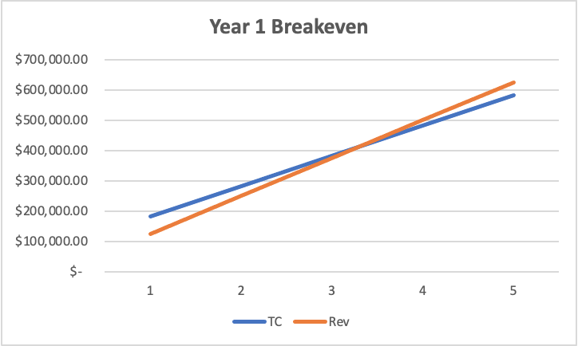

**Management Team**

**Jewel Loff-CEO**

Ms. Loff holds a master’s in finance from California State University, Long Beach. She has held senior management positions in the fields of banking, finance, healthcare, and most recently with a start-up technology company.

**Summer Shields, CPA-CFO**

Mr. Shields has been a licensed Certified Public Account since 2003. Mr. Shields completed his master’s in accounting at Stanford University. He spent 10 years with Deloitte specializing in audits and tax planning. Mr. Shields has served on the board of directors for several small start-up tech firms during the past 5 years.

**Kisha  Gladden, Chief Marketing Officer**

Ms. Gladden holds a master’s in marketing from Harvard University. She has held senior level marketing positions for several marketing and advertising agencies, most recently and Marketing Director for the largest advertising and marketing company in the U.S., where she specialized in marketing of technology companies.

**Stephanie Balderama, Chief Sales Officer**

Ms. Balderama holds a master’s in finance and marketing from Tulane University. She has been instrumental in the sales success of several large consumer convenience companies. Ms. Balderama previously served as Senior Sales Strategist for a biotech company prior to joining My Personal Chef.